KUTUMBA
Families Growing in Kṛṣṇa Consciousness
FESTIVALS, YĀTRĀS, OUTDOOR ACTIVITIES
AND ANNUAL CALENDAR
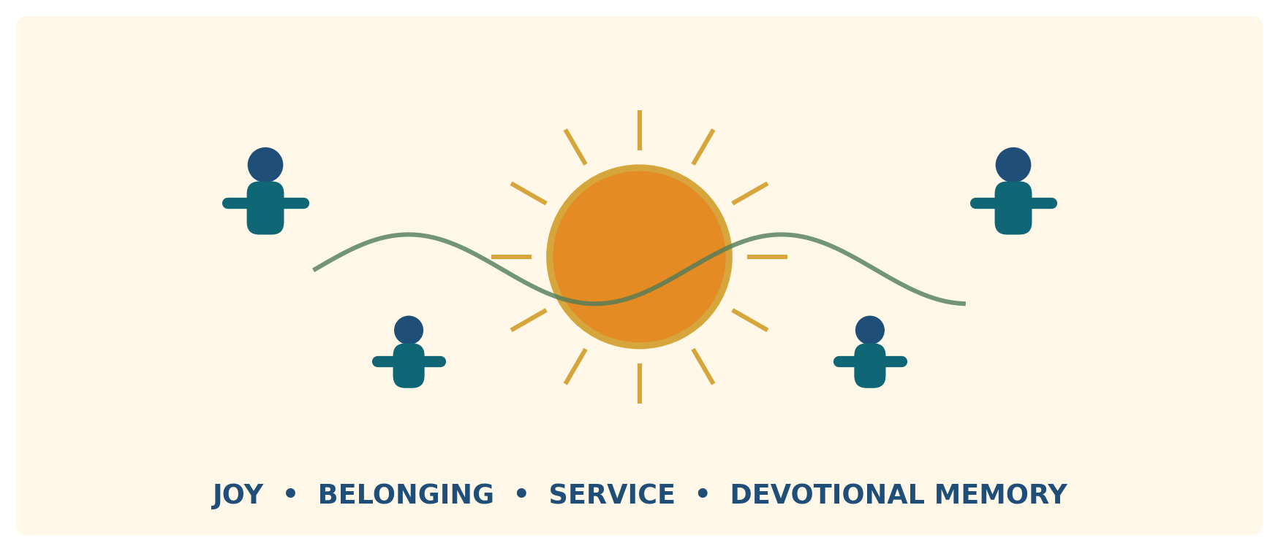
A Kṛṣṇa-centred experiential calendar: joyful, bounded, safe and purposeful.
Research-backed working framework
Version 1.0 | 29 June 2026
Document status
Designed for the founding cohort and subsequent annual planning. Permanent policy is separated from dates, prices, venue details and legal requirements that must be refreshed each year.

Document control
Field | Value
Document owner | KUTUMBA Documentation and Calendar Lead
Governance reviewers | Program Director; Curriculum and Philosophy Lead; Children and Safety Lead; Temple Liaison
Operational reviewers | Event Lead; Prasāda Lead; Transport Coordinator; host venue representative
Version | 1.0 — initial integrated working framework
Review cycle | Annually before publication; event-specific review before every outing
Primary audience | Core team, facilitators, parent volunteers, temple liaison and future program reviewers
Not a substitute for | Temple direction, qualified worship guidance, venue rules, insurance advice, medical advice or legal review

Purpose of this document
This document converts the KUTUMBA master operating model into a practical experiential-calendar system. It governs festivals, pilgrimages, cow and temple service, nature activities, informal gatherings, travel, safety, budgeting and post-event learning for a small US-based family cohort.
The design objective is not to maximize the number of events. It is to create a limited number of memorable experiences that deepen hearing, chanting, service, family bonds and meaningful connection with temple life without producing calendar overload.

How to use it
1. Adopt Sections 1–3 as permanent program policy.
2. Build the next year’s calendar using the annual workflow in Section 4.
3. Use the festival and venue playbooks to design each selected experience.
4. Complete the event brief, risk review, permissions and emergency plan from the appendices.
5. After the event, capture learning and operational defects so the next version improves.

Key assumptions
• Cohort size: approximately five to six families and 20–25 participants.
• Geographic base: Central Pennsylvania, with regional day trips and occasional travel to nearby ISKCON communities.
• Annual rhythm: 40 active KUTUMBA weeks and 12 protected non-program weeks.
• Child responsibility: parents remain responsible unless a child is formally checked into a designated KUTUMBA activity.
• Calendar authority: festival dates, fasting and pāraṇa are taken from the locally applicable authorized ISKCON calendar and temple guidance, not hard-coded in this document.

Contents
Section | Title | Page | Section | Title | Page
1 | Identity, scope and non-negotiables | 5 | 9 | Event governance and risk | 31
2 | Annual architecture: 40 / 12 | 8 | 10 | Safeguarding, inclusion and media | 34
3 | Calendar build and seasonal map | 11 | 11 | Transport and carpooling | 36
4 | Festival playbooks | 14 | 12 | Medical, food, weather and emergency | 38
5 | Gītā Valley, New Vrindaban and temples | 21 | 13 | Budget and affordability | 40
6 | Dhāma education and yātrā mood | 24 | 14 | Communication, forms and packing | 42
7 | Outdoor and informal activities | 26 | 15 | Reflection and measurement | 45
8 | Dramas, quizzes and presentations | 29 | 16 | Implementation roadmap | 47
A | 52-week calendar worksheet | 48 | F | Family reflection sheet | 54
B | Event brief | 50 | G | Event review | 55
C | Risk assessment | 51 | H | Research and source register | 56
D | Emergency plan | 52 | I | Final readiness gate | 59
E | Carpool manifest | 53

Navigation note
All major headings use Word heading styles and appear in the Navigation Pane. The printed page numbers above are verified for this version.

Executive decision summary
Decision | Adopted working rule
Annual load | Exactly 40 active weeks; outings replace rather than supplement the normal weekly program.
Replacement portfolio | Four principal experiential weeks per year.
Festival treatment | Use replacement, integrated-Friday or home/optional observance tiers.
Year 1 portfolio | One local Ratha-yātrā; Janmāṣṭamī week; Gītā Valley cow/service day; one local Kṛṣṇa-centred nature retreat.
Regional overnight | New Vrindaban no earlier than Year 2 and only after successful local operations.
High-risk recreation | No KUTUMBA kayaking in Year 1; later use a qualified operator and stronger-than-minimum controls.
International yātrā | Not a founding-stage project; use qualified ISKCON/temple leadership and strict readiness gates.
Non-negotiable test | Removing hearing, chanting, service, prasāda and reflection must materially change the nature of the event.

1 | Identity, scope and non-negotiables  Why KUTUMBA runs experiential activities and what keeps them devotional.

1.1 Experiential formation purpose
Festivals and yātrās are not rewards added after “real learning.” They are part of the learning system. Children and adults remember what they hear more deeply when they also sing, walk, serve, observe, present, travel, honor prasāda and reflect together.
The master operating model already places utsava and yātrā among KUTUMBA’s core methods and requires that every picnic, trek, farm visit or informal gathering retain a real spiritual centre. The same model fixes the no-overloading rule: one principal program per week, protected breaks and no competition in service or participation [S01].

1.2 Six experiential outcomes
Outcome | What success looks like
Joy | Families associate devotional life with warmth, beauty, service and meaningful shared experiences.
Belonging | Participants know one another through service and reliability, not gossip, status or private factions.
Devotional memory | Children and adults can recall a person, pastime, teaching, place or service after the event.
Practice | The event results in at least one realistic home or temple practice.
Temple connection | KUTUMBA participation increases respect for and service to temple life rather than replacing it.
Character | Punctuality, cleanliness, humility, cooperation, responsibility and care for living beings improve.

1.3 Five devotional anchors
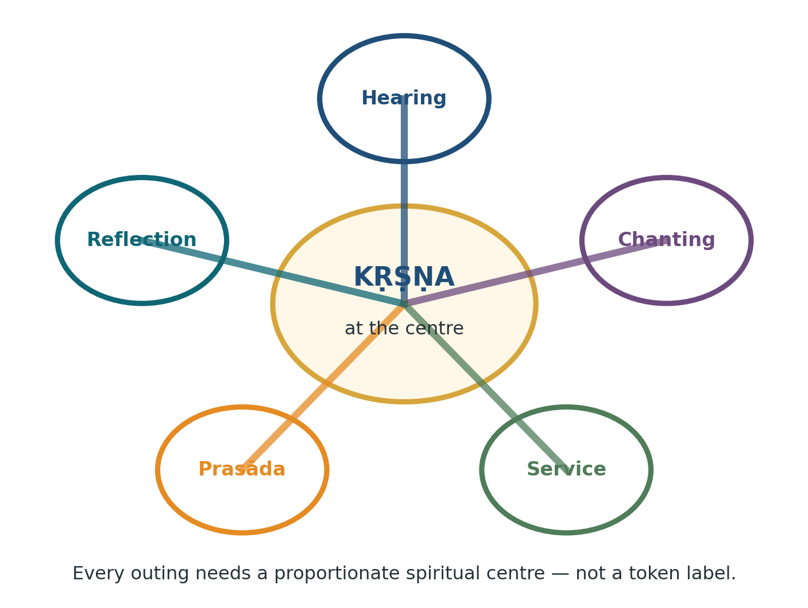
Figure 1. Five anchors that keep an activity Kṛṣṇa-centred.
Every activity uses these anchors proportionately. A short park meeting may need a five-minute prayer, a fifteen-minute story and a closing reflection. A full yātrā needs a stronger sādhana, hearing and service structure. Token devotional branding is not enough.

1.4 Non-negotiable boundaries
• No event is added merely because it is attractive, popular or available.
• No activity becomes a competition in cooking, costume, singing, knowledge, travel spending or children’s performance.
• No independent worship procedure, fasting rule, Deity practice or festival ritual is invented by KUTUMBA.
• No child is forced to stay late, fast, perform, hike beyond capacity or join a frightening dramatization.
• No temple, farm or venue is treated as a consumer attraction; the host’s devotional and operational authority is respected.
• No expensive event is presented as a test of faith or belonging.
• No protected rest week is casually converted into another KUTUMBA obligation.
• No confidential family, child, medical or transport information is stored in Git or published in group channels.
The “ordinary outing” test
Ask: If hearing, chanting, service, prasāda and reflection were removed, would the gathering still be essentially the same? If yes, it is probably ordinary recreation carrying a KUTUMBA label. Redesign it or do not make it an official event.

1.5 Scriptural and institutional basis
• Śrīmad-Bhāgavatam 7.14 connects household life with repeated saintly association, hearing, prasāda distribution, care for living beings and visiting holy places [S03].
• Caitanya-caritāmṛta, Madhya 13 describes Ratha-yātrā through kīrtana, dancing, service and the mercy of Lord Jagannātha [S04].
• The GBC adopted a multi-calendar approach because observances must be calculated for local conditions rather than imposed from one global time zone [S02].
• KUTUMBA therefore teaches the meaning and conduct of observances while relying on the local temple and authorized calendar for dates and exact practice.

2 | Annual architecture: 40 active weeks, 12 protected weeks  The calendar is a capacity-control system, not a wish list.

2.1 Fixed annual mathematics
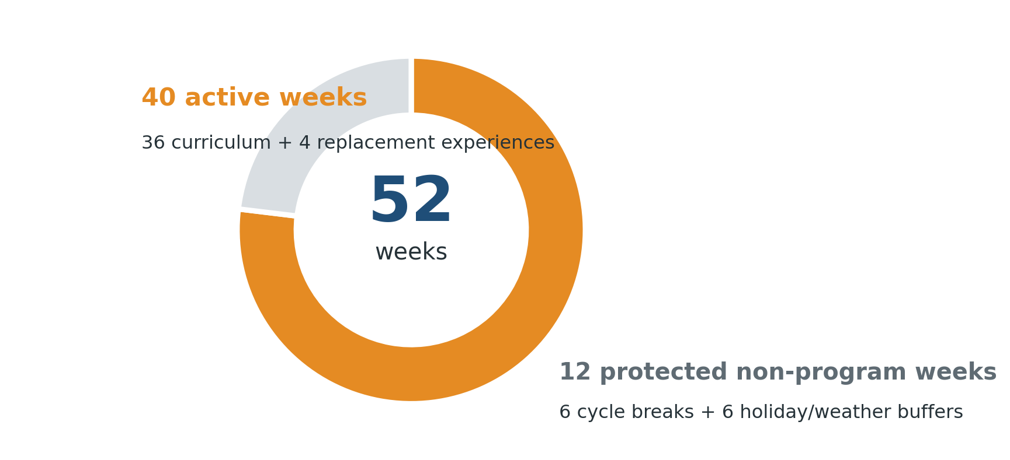
Figure 2. The fixed 52-week KUTUMBA rhythm.
Calendar component | Active | Non-program | Total
Six learning cycles: six active weeks plus one off week each | 36 | 6 | 42
Festival, pilgrimage, service or outdoor replacement experiences | 4 | 0 | 4
Holiday, vacation, severe-weather and family buffers | 0 | 6 | 6
Annual total | 40 | 12 | 52

Capacity rule
Festival-integrated Fridays remain inside the 36 curriculum weeks. A trip, public festival or service day uses one of the four replacement weeks. No event is “free” simply because it occurs on a Saturday.

2.2 Three-tier observance model
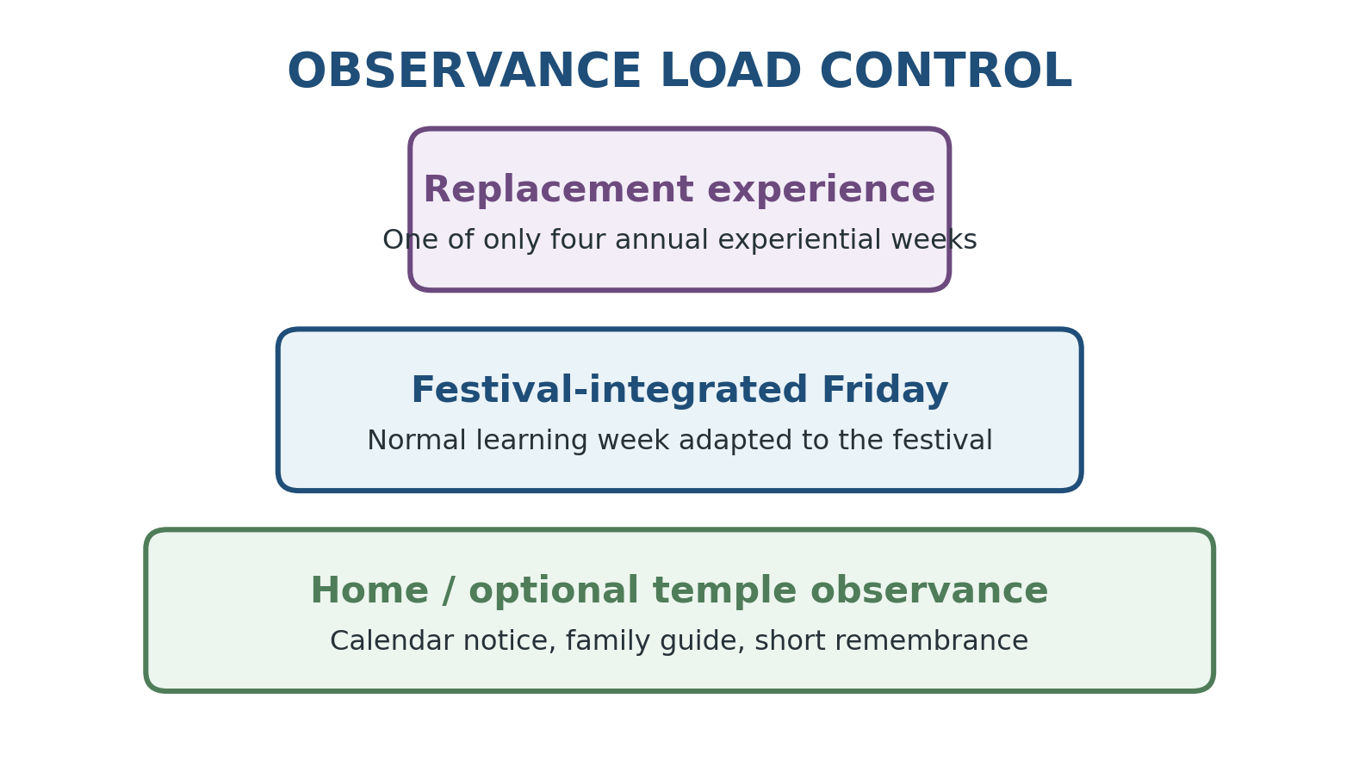
Figure 3. Three tiers prevent festival overload.
Tier | Use | Typical examples | Approval
A — Replacement experience | Consumes one of four annual experiential slots. | One Ratha-yātrā, Janmāṣṭamī week, Gītā Valley, nature retreat or regional yātrā. | Core team; Safety Lead may veto.
B — Festival-integrated Friday | Normal active week adapted to the observance. | Gaura-pūrṇimā, Rāma-navamī, Nṛsiṁha-caturdaśī, Govardhana-pūjā, Gītā Jayantī. | Curriculum Lead and Worship Lead.
C — Home / optional temple | No KUTUMBA gathering created. | Other appearance/disappearance days, temple observances, family vows. | Calendar notice only.

2.3 Recommended Year 1 replacement portfolio
Slot | Experience | Why it earns a replacement week | Hard boundary
1 | One local Ratha-yātrā | Public saṅkīrtana, Jagannātha darśana, temple service and family memory. | Only one local festival is official; additional attendance is personal.
2 | Janmāṣṭamī week | Central Kṛṣṇa festival with temple participation and child-accessible preparation. | No pressure for children to remain awake until midnight or fast.
3 | Gītā Valley cow/service day | Go-sevā, land, compassion, farm learning and regional temple connection. | Host-assigned service only; farm hygiene and animal rules apply.
4 | Local nature retreat | Low-cost, inclusive outdoor formation with kīrtana, japa walk, prasāda and reflection. | Not an unstructured picnic; clear start, end and spiritual theme.

2.4 Year 2 and Year 3 progression
Year | Portfolio development | Readiness gate
Year 1 | Local, low-complexity portfolio; no overnight and no paddlesport. | Prove check-in, transport, weather, food, incident and review processes.
Year 2 | Consider one-night New Vrindaban yātrā; introduce a professionally operated kayaking option only if demanded and justified. | Three successful local outings; trained leads; insurance/venue confirmation; parent confidence.
Year 3 | Deeper temple service, leadership roles and possible participation in a temple-led national/international yātrā. | Stable governance, financial transparency, qualified guide, medical and safeguarding readiness.

2.5 Festival classification matrix
Observance | Default treatment | Learning emphasis | Optional family/temple action
Gaura-pūrṇimā | Integrated Friday | Mahāprabhu, saṅkīrtana and Māyāpur. | Temple festival according to local calendar.
Rāma-navamī | Integrated Friday | Duty, protection, truthfulness and Hanumān’s service. | Temple attendance or home reading.
Nṛsiṁha-caturdaśī | Integrated Friday | Prahlāda’s remembrance, courage and protection. | Temple prayers; age-sensitive storytelling.
Ratha-yātrā | Replacement | Lord Jagannātha, public kīrtana, humble service. | Additional festivals remain optional.
Janmāṣṭamī | Replacement | Kṛṣṇa’s appearance, gratitude, service and hearing. | Parents choose child-appropriate temple schedule.
Śrīla Prabhupāda Vyāsa-pūjā | Temple or integrated segment | Founder-Ācārya, gratitude and mission. | Family offering or service; no performance pressure.
Rādhāṣṭamī | Short integrated observance | Śrīmatī Rādhārāṇī’s service mood, taught carefully. | Temple attendance.
Dāmodara month | Four-week progression | Mother Yaśodā’s loving service; Dāmodarāṣṭakam; safe lamp offering. | Approved home observance.
Govardhana-pūjā | Integrated Friday | Kṛṣṇa’s protection, cows, land, gratitude and prasāda. | Temple Annakūṭa.
Gītā Jayantī | Integrated Friday | Why Bhagavad-gītā was spoken; reading and application. | Book gifting or family study commitment.

3 | Annual calendar build and seasonal map  A repeatable workflow that is refreshed every year.

3.1 Calendar authority and annual refresh
The annual calendar must be generated from the locally applicable Vaiṣṇava calendar and the designated temple’s published schedule. The GBC’s multi-calendar policy recognizes that location matters [S02]. Do not copy dates from an Indian calendar, a social-media post or the previous year.
1. By 15 October, obtain the authorized calendar source and the local temple’s provisional festival schedule.
2. Mark school breaks, family travel periods, major temple events and severe-weather buffers.
3. Place the six curriculum-cycle breaks first and protect them.
4. Select only four replacement experiences using the portfolio rules.
5. Map integrated festival Fridays to the relevant curriculum theme.
6. Review clashes, costs, travel time, host capacity and child burden.
7. Temple Liaison verifies public-festival and service assumptions.
8. Children and Safety Lead reviews every off-site or late-night item.
9. Publish the annual calendar by 15 December with a “dates subject to authorized update” note.
10. Reconfirm each event quarterly and again at its formal planning gates.

3.2 Seasonal portfolio
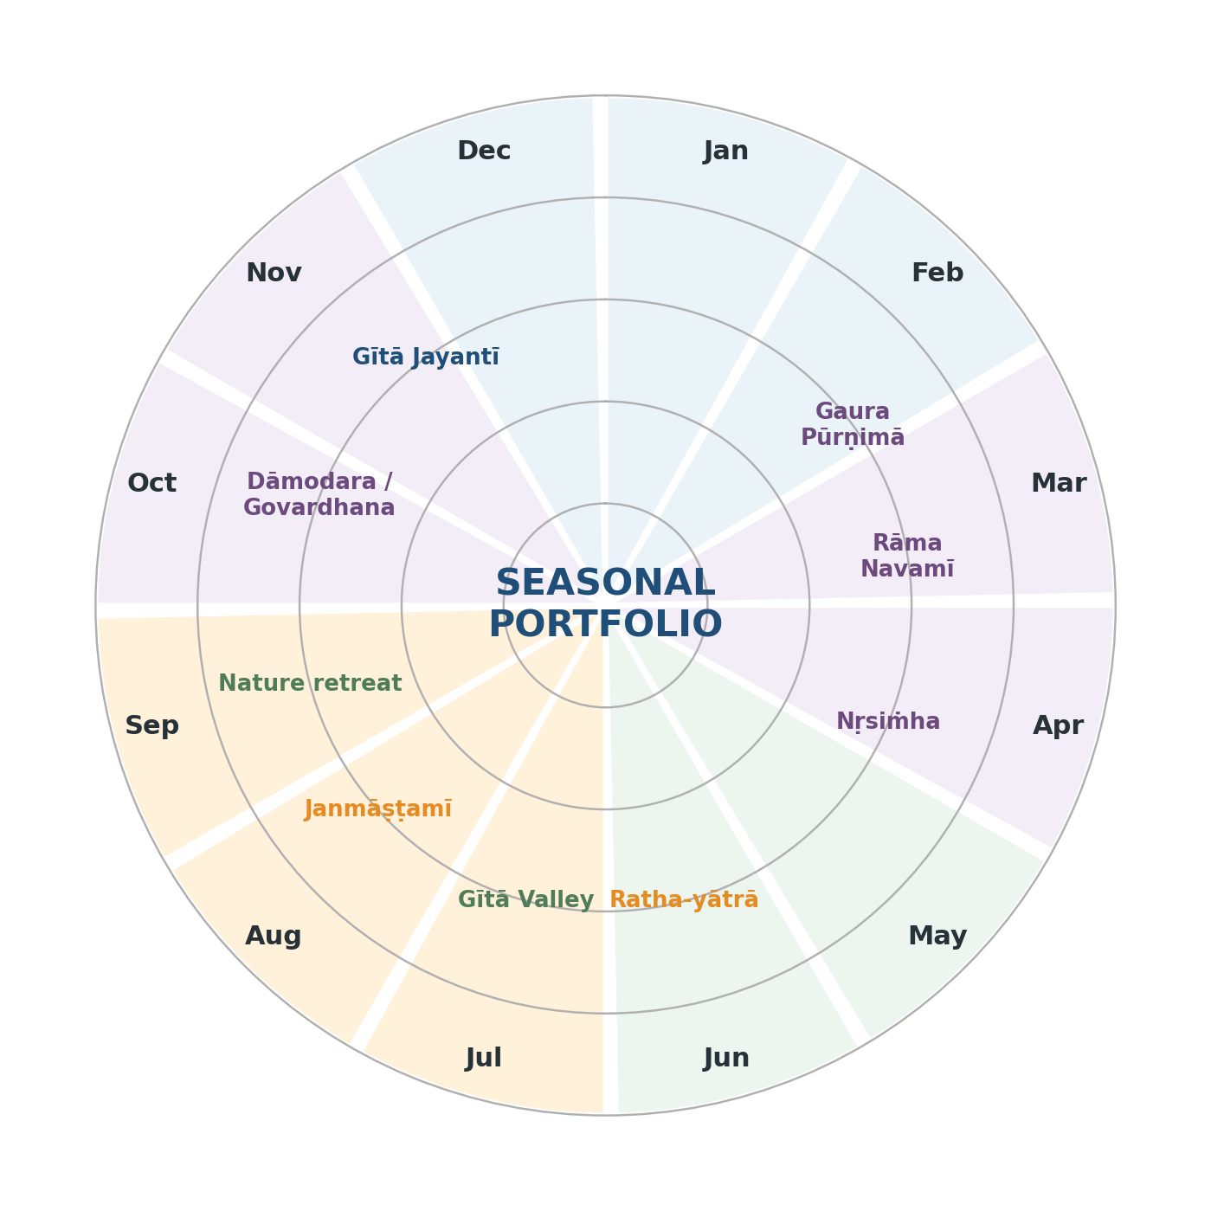
Figure 4. Perpetual seasonal portfolio; exact Gregorian dates change annually.
Seasonal period | Primary emphasis | Calendar guidance
January–February | Indoor curriculum, ācārya remembrance, temple service. | Preserve winter/weather buffers.
February–March | Gaura-pūrṇimā and Māyāpur glorification. | Integrated Friday plus optional temple participation.
March–April | Rāma-navamī. | Integrated lesson, drama or Hanumān service challenge.
April–May | Nṛsiṁha-caturdaśī. | Age-sensitive integrated observance.
May–July | Local Ratha-yātrā. | Use one replacement slot and one official festival only.
July–August | Gītā Valley cow and service visit. | Use replacement slot; avoid extreme heat.
August–September | Janmāṣṭamī and Vyāsa-pūjā. | Replacement week plus temple/home observance.
September–October | Local nature retreat or, in later years, regional yātrā. | Use replacement slot; keep costs bounded.
October–November | Dāmodara month and Govardhana-pūjā. | Four-week home/Friday progression.
November–December | Gītā Jayantī, presentations and annual review. | Integrated week; protect holiday breaks.

3.3 Selection scorecard for replacement events
Criterion | Weight | Question
Devotional value | 25% | Will participants hear, chant, serve, remember and connect to authorized teaching?
Cohort accessibility | 20% | Can young children, older adults, busy parents and varied incomes participate?
Temple/host relationship | 15% | Does it strengthen appropriate temple or community service?
Safety and control | 20% | Can KUTUMBA reliably manage transport, weather, supervision and emergency response?
Cost and burden | 10% | Is the financial and time cost proportionate to the value?
Curriculum fit | 10% | Does the activity reinforce the current learning cycle?

Decision threshold
Do not select an event that scores poorly in safety or accessibility even when its devotional value is high. A spiritually attractive event that the group cannot operate safely is not ready.

3.4 Change-control rules
• A date change does not automatically preserve the event; rerun transport, cost, host and weather checks.
• A new event can replace an approved slot only through the Program Director and Safety Lead.
• A cancelled event usually becomes a rest week or home guide; it is not automatically rescheduled.
• A festival date correction is communicated as an authorized calendar update, not treated as an error by families.
• The published calendar shows mandatory KUTUMBA events, optional temple observances and protected weeks distinctly.

4 | Festival playbooks  Meaning, delivery, age adaptation, service and boundaries.

4.1 Gaura-pūrṇimā
Core understanding
Śrī Caitanya Mahāprabhu appeared to teach and distribute devotion through saṅkīrtana.

Primary source: Caitanya-caritāmṛta, Ādi 3 [S05].
Dimension | Working design
Friday / event flow | Opening kīrtana or prayer; authorized narrative; age-appropriate formation; practical service or presentation; family application; closing reflection.
Adult formation | Connect the festival principle to family duty, speech, habits, service, temple relationship or sādhana.
Child formation | Story, song/prayer, one memorable quality, one participatory activity and one service.
Home continuation | One small practice for 3–7 days; no public scoring.
Assessment | Can the family explain the festival’s central principle and one application?

Recommended components
• Pañca-tattva mantra and mahā-mantra kīrtana.
• Appearance narrative and simple map of Navadvīpa/Māyāpur.
• Family application: make the home more welcoming to the holy name.
• Child procession, call-and-response or approved short drama.
Boundaries and risks
• Do not invent an abhiṣeka, fasting rule or worship sequence.
• Keep advanced identity and confidential līlā explanations with qualified teachers.
• Māyāpur glorification must not become tourism marketing.

4.2 Rāma-navamī
Core understanding
Lord Rāmacandra demonstrates truthfulness, responsibility, protection and service.

Primary source: Śrīmad-Bhāgavatam 9.10 [S06].
Dimension | Working design
Friday / event flow | Opening kīrtana or prayer; authorized narrative; age-appropriate formation; practical service or presentation; family application; closing reflection.
Adult formation | Connect the festival principle to family duty, speech, habits, service, temple relationship or sādhana.
Child formation | Story, song/prayer, one memorable quality, one participatory activity and one service.
Home continuation | One small practice for 3–7 days; no public scoring.
Assessment | Can the family explain the festival’s central principle and one application?

Recommended components
• Concise authorized Rāmāyaṇa narrative.
• Parent case study: duty under pressure without anger or self-righteousness.
• Children’s drama focused on service, courage and loyalty.
• One-week “Hanumān service challenge.”
Boundaries and risks
• Avoid political, nationalistic or culture-war framing.
• Do not use graphic battle scenes for young children.
• Do not turn ideal examples into public judgment of marriages or families.

4.3 Nṛsiṁha-caturdaśī
Core understanding
Prahlāda remembered the Lord under pressure; the Lord protected His devotee.

Primary source: Śrīmad-Bhāgavatam 7.8–9 [S07].
Dimension | Working design
Friday / event flow | Opening kīrtana or prayer; authorized narrative; age-appropriate formation; practical service or presentation; family application; closing reflection.
Adult formation | Connect the festival principle to family duty, speech, habits, service, temple relationship or sādhana.
Child formation | Story, song/prayer, one memorable quality, one participatory activity and one service.
Home continuation | One small practice for 3–7 days; no public scoring.
Assessment | Can the family explain the festival’s central principle and one application?

Recommended components
• Prahlāda narrative centered on remembrance and courage.
• Approved Nṛsiṁha prayers from the KUTUMBA prayer canon.
• Child exercise: courage versus aggression.
• Family prayer for spiritual protection and steadiness.
Boundaries and risks
• No graphic killing reenactment.
• Prepare sensitive children before showing intense images or sounds.
• Do not promise that devotion removes every material difficulty.

4.4 Ratha-yātrā
Core understanding
Lord Jagannātha comes into public view, and devotees serve through kīrtana, humility and cooperation.

Primary source: Caitanya-caritāmṛta, Madhya 13 [S04].
Dimension | Working design
Friday / event flow | Opening kīrtana or prayer; authorized narrative; age-appropriate formation; practical service or presentation; family application; closing reflection.
Adult formation | Connect the festival principle to family duty, speech, habits, service, temple relationship or sādhana.
Child formation | Story, song/prayer, one memorable quality, one participatory activity and one service.
Home continuation | One small practice for 3–7 days; no public scoring.
Assessment | Can the family explain the festival’s central principle and one application?

Recommended components
• Pre-event lesson on Jagannātha, Baladeva and Subhadrā.
• Crowd, rope, meeting-point and child-safety briefing.
• One host-approved service assignment.
• Fixed check-in and departure process.
Boundaries and risks
• No climbing on carts, barriers or restricted structures.
• No independent service that conflicts with organizers.
• One official Ratha-yātrā per year; extra festivals are personal.

4.5 Janmāṣṭamī
Core understanding
Kṛṣṇa is the Supreme Personality of Godhead and appears for the protection of devotees and restoration of dharma.

Primary source: Bhagavad-gītā 4.7–8 and Śrīmad-Bhāgavatam 10.3 [S08].
Dimension | Working design
Friday / event flow | Opening kīrtana or prayer; authorized narrative; age-appropriate formation; practical service or presentation; family application; closing reflection.
Adult formation | Connect the festival principle to family duty, speech, habits, service, temple relationship or sādhana.
Child formation | Story, song/prayer, one memorable quality, one participatory activity and one service.
Home continuation | One small practice for 3–7 days; no public scoring.
Assessment | Can the family explain the festival’s central principle and one application?

Recommended components
• Five-day family Kṛṣṇa Book or Bhāgavatam reading plan.
• Child-accessible early program with story, kīrtana and service.
• Temple service or approved home offering.
• Family gratitude: what Kṛṣṇa’s appearance changes in our lives.
Boundaries and risks
• No comparison of fasting, wakefulness, dress, decoration or offerings.
• Children are not pressured to remain awake until midnight.
• Exact fasting and pāraṇa come from the local temple/calendar.

4.6 Dāmodara month
Core understanding
Mother Yaśodā’s loving service shows how the unlimited Lord becomes bound by devotion.

Primary source: Śrīmad-Bhāgavatam 10.9 [S09].
Dimension | Working design
Friday / event flow | Opening kīrtana or prayer; authorized narrative; age-appropriate formation; practical service or presentation; family application; closing reflection.
Adult formation | Connect the festival principle to family duty, speech, habits, service, temple relationship or sādhana.
Child formation | Story, song/prayer, one memorable quality, one participatory activity and one service.
Home continuation | One small practice for 3–7 days; no public scoring.
Assessment | Can the family explain the festival’s central principle and one application?

Recommended components
• Week 1: Mother Yaśodā’s service and effort.
• Week 2: Dāmodarāṣṭakam meaning and pronunciation.
• Week 3: approved lamp-offering practice and fire safety.
• Week 4: home observance, gratitude and reflection.
Boundaries and risks
• Adults control ignition and flame.
• Use stable nonflammable surfaces and extinguish/count lamps.
• Do not turn daily lamp photos or streaks into competition.

4.7 Govardhana-pūjā
Core understanding
Kṛṣṇa protects His devotees and teaches gratitude toward cows, land, food and the devotional community.

Primary source: Śrīmad-Bhāgavatam 10.24–27 [S10].
Dimension | Working design
Friday / event flow | Opening kīrtana or prayer; authorized narrative; age-appropriate formation; practical service or presentation; family application; closing reflection.
Adult formation | Connect the festival principle to family duty, speech, habits, service, temple relationship or sādhana.
Child formation | Story, song/prayer, one memorable quality, one participatory activity and one service.
Home continuation | One small practice for 3–7 days; no public scoring.
Assessment | Can the family explain the festival’s central principle and one application?

Recommended components
• Govardhana narrative and gratitude discussion.
• Cow-protection and Gītā Valley connection.
• Child craft, drama or landscape activity.
• Family gratitude for rain, land, food, cows and prasāda.
Boundaries and risks
• A craft hill is not treated as a worshipable Deity.
• Actual Annakūṭa or Govardhana worship follows temple guidance.
• Avoid food-display competition and waste.

4.8 Gītā Jayantī
Core understanding
Bhagavad-gītā gives Kṛṣṇa’s direct instruction on identity, duty, surrender and bhakti.

Primary source: Bhagavad-gītā, especially 18.66 [S11].
Dimension | Working design
Friday / event flow | Opening kīrtana or prayer; authorized narrative; age-appropriate formation; practical service or presentation; family application; closing reflection.
Adult formation | Connect the festival principle to family duty, speech, habits, service, temple relationship or sādhana.
Child formation | Story, song/prayer, one memorable quality, one participatory activity and one service.
Home continuation | One small practice for 3–7 days; no public scoring.
Assessment | Can the family explain the festival’s central principle and one application?

Recommended components
• Why the Gītā was spoken; setting and chapter map.
• Selected verse recitation with meaning.
• Family application stations and reading commitment.
• Book gifting or host-approved distribution service.
Boundaries and risks
• Do not reduce the day to competitive recitation.
• Use Śrīla Prabhupāda’s edition as the primary KUTUMBA source.
• Commitments must be realistic for working families.

4.9 Śrīla Prabhupāda appearance and disappearance observances
These observances should cultivate gratitude, careful hearing and commitment to Śrīla Prabhupāda’s mission. They must not become polished performance events in which families compete to offer elaborate speeches or gifts.
Component | Working standard
Source | Approved biography, recorded lecture, letter or direct passage from Śrīla Prabhupāda’s books.
Family offering | One sincere gratitude, one instruction being applied or one service commitment.
Children | Short incident, timeline, drawing, memorized quotation or service display.
Temple relationship | Prefer participation in the temple’s observance and follow its program.
Boundary | Do not invent biographical stories or circulate unverified quotations.

4.10 Other appearance and disappearance days
KUTUMBA cannot give equal program time to every calendar observance. Use a reviewed annual remembrance canon tied to the curriculum, prayer library and local temple schedule.
Step | Five-minute remembrance protocol
1 | Display an approved image or title card.
2 | State one verified biographical fact.
3 | Read one brief teaching or incident from an approved source.
4 | Name one quality or service.
5 | Give one family application.
6 | Offer an appropriate prayer, verse or kīrtana.

Year 1 priority canon
Śrīla Prabhupāda; Śrīla Bhaktisiddhānta Sarasvatī Ṭhākura; Śrīla Bhaktivinoda Ṭhākura; Śrīla Haridāsa Ṭhākura; and Śrīla Narottama dāsa Ṭhākura when connected to songs being learned. Add others only through curriculum review.

5 | Gītā Valley, New Vrindaban and temple relationships  Venue-specific models that preserve host authority and devotional purpose.

5.1 Gītā Valley cow and service day
Gītā Valley (also known historically as Gītā Nāgarī) is a 430-acre Pennsylvania farm that describes its mission through regenerative, slaughter-free farming, compassionate living, tours, workshops, lodging and cow care [S12]. KUTUMBA should arrange a visit directly with the host rather than arrive as an informal recreation group.
Educational purpose
This is not a petting-zoo outing. The day should help families understand go-rakṣya, lifelong care, land, food, farm work, compassion and practical service.

Time | Sample day
08:00 | Depart agreed meeting point; transport manifest activated.
09:30 | Arrival, headcount, restrooms and host orientation.
10:00 | Temple darśana or guided hearing, subject to host schedule.
10:45 | Cow-protection / farm presentation.
11:15 | Host-assigned age-appropriate service.
12:30 | Tool return, footwear control and supervised handwashing.
13:00 | Prasāda.
13:45 | Nature/farm walk or cow observation.
14:30 | Family reflection and short kīrtana.
15:00 | Departure and headcount.

5.1.1 Farm controls
• Closed-toe shoes are mandatory; work gloves and washable clothing are recommended.
• No participant enters a pasture, barn, workshop, machinery area or animal enclosure without host permission.
• No one feeds, leads, hugs or touches an animal unless the host directs it.
• Children do not stand behind cows or between an animal and an exit.
• Food and drink remain outside animal areas; hands are washed with soap and water immediately after contact.
• Adults supervise young children’s handwashing. CDC notes that healthy-looking farm animals and their environments can carry germs [S17].
• Service tasks are based on age and host assessment; children do not use machinery, chemicals or sharp tools.
• Photography follows host rules; animals are not props for social-media content.

5.2 New Vrindaban regional yātrā
New Vrindaban in West Virginia offers temple programs, Prabhupāda’s Palace of Gold, lodging and family rooms, making it a viable later-stage regional yātrā [S13–S14]. It should not be forced into Year 1. The travel, lodging, cost and child-supervision complexity are materially higher than a local day trip.
Decision | Recommended standard
Earliest year | Year 2, after three successfully operated local outings.
Format | One overnight; avoid a rushed same-day return.
Children | Travel and lodge with their own parent/guardian.
Rooms | Family rooms; no unrelated adult shares sleeping space with a child.
Devotional content | Temple program, hearing, Prabhupāda remembrance, go-sevā if officially available, family japa/walk, prasāda and reflection.
Schedule | Protect sleep and avoid late-night/early-morning overload for young children.
Commercial boundary | The Palace, dining and photographs do not constitute a yātrā by themselves.

5.3 Local Ratha-yātrās and temple festivals
The Harrisburg temple maintains a Festival of India/Ratha-yātrā program and provides a natural local relationship for KUTUMBA [S15]. The annual official event should be whichever one best satisfies timing, temple relationship, safety, travel and service—not whichever is largest or most prestigious.
Before | During | After
Temple Liaison confirms date, route, service, arrival, parking and child meeting point. | Families check in as units; leaders do scheduled headcounts. | Families check out; transport coordinator confirms departures.
Children learn Jagannātha identity, festival meaning and crowd rules. | Parents retain custody unless formal children’s check-in exists. | Complete a short reflection within 24 hours.
Assign one realistic host-approved service. | Follow organizer instructions; no restricted-area access. | Thank the host and record operational defects.

5.4 Temple-service outings
Temple service is requested, not invented. The local service coordinator decides what is needed, who may perform it and what training or access restrictions apply.
Suitable examples | Restricted without specific authorization
Room and chair setup; cleaning; grounds cleanup; serving prasāda; packing approved materials; festival preparation; flower support; book-table assistance. | Deity-room access; bhoga offering; hot kitchen equipment; chemicals; ladders; sharp tools; electrical work; unsupervised child roles; restricted photography.

On-site authority
At a temple, farm, festival or retreat, KUTUMBA remains responsible for its internal supervision and conduct but accepts the host’s authority on access, service, worship, food, photography and emergency procedures.

6 | Dhāma education and proper yātrā mood  Vṛndāvana and Māyāpur are glorified before they are visited.

6.1 Annual Māyāpur and Vṛndāvana glorification
Dhāma | Best annual connection | Core teaching
Māyāpur / Navadvīpa | Gaura-pūrṇimā cycle. | Mahāprabhu’s appearance, saṅkīrtana, hearing, service and the global mission.
Vṛndāvana / Vraja | Dāmodara month and Govardhana-pūjā. | Kṛṣṇa’s childhood pastimes, cows, Govardhana, Yamunā, simple loving service and respect for the dhāma.

• Use maps, authorized photographs, short readings, songs, models, service projects and age-appropriate pastimes.
• Teach respect for residents, sādhus, cows, water, sacred places and other pilgrims.
• Do not prematurely teach confidential pastimes to children or spiritually inexperienced adults.
• Do not imply that a virtual presentation is equivalent to pilgrimage; it is preparation and glorification.

6.2 Future international yātrā readiness gate
☐ KUTUMBA has operated stably for at least 18–24 months. | ☐ A qualified ISKCON/temple yātrā leader—not KUTUMBA alone—is responsible for spiritual guidance.
☐ Temple leadership and the KUTUMBA core team approve the relationship and scope. | ☐ Families receive transparent itinerary, cost, cancellation and refund terms.
☐ No family is pressured to attend or disclose financial inability. | ☐ Minors travel with their parent/guardian; no child-only international trip.
☐ Medical, insurance, passport, visa, safeguarding and emergency plans are complete. | ☐ The itinerary prioritizes hearing, sādhana, service, darśana and rest over shopping and location counting.
☐ The trip does not undermine household duties, debt obligations, school responsibilities or health. | ☐ Post-yātrā integration is planned so inspiration becomes practice.

6.3 Dhāma-yātrā covenant
We will | We will not
Travel as pilgrims; follow the authorized guide; maintain chanting and hearing. | Treat the dhāma as a leisure product, photo backdrop or shopping tour.
Respect residents, sādhus, cows, sacred water, temples and other pilgrims. | Gossip, criticize arrangements constantly or create factions.
Dress and behave appropriately; keep sacred places clean. | Photograph restricted areas or vulnerable people without permission.
Accept reasonable simplicity and protect children’s rest and safety. | Overpack the itinerary or shame families who need rest.
Ask before performing rituals or collecting sacred items. | Experiment with independent rituals or remove objects from sacred places.

Readiness principle
A yātrā is not made spiritually successful by distance. A well-led local temple visit can produce more genuine hearing and service than an expensive international tour operated as devotional tourism.

7 | Outdoor and informal activity standards  Joyful activities that remain bounded, inclusive and Kṛṣṇa-centred.

7.1 Activity portfolio and staging
Activity | Devotional centre | Risk | Earliest year
Park prasāda picnic | Kīrtana, story, gratitude, service and reflection. | Low | 1
Japa walk | Holy name, quiet observation and respectful public conduct. | Low | 1
Nature observation | Seeing Kṛṣṇa’s energies; care for living beings and place. | Low | 1
Short family trek | Effort, cooperation, remembrance and shared service. | Medium | 1
Longer hike | Endurance, nature, teamwork and reflective hearing. | Medium | 2
Informal ice-cream gathering | Brief remembrance and controlled family association. | Low | 1
Kayaking | Cooperation, gratitude and nature, with professional operations. | High | 2+
Overnight camping | Simplicity, sādhana, service and shared responsibility. | High | 3+

7.2 Kṛṣṇa-centred picnic
• Publish a named devotional theme and simple schedule.
• Open with 10–20 minutes of proportionate kīrtana or prayer.
• Include one story, guided discussion, nature observation or service.
• Use properly handled prasāda; do not let food become a family-status display.
• Provide organized, inclusive games and a quiet option.
• Close at the announced time with gratitude and one family takeaway.

7.3 Japa walk
Group | Method
Adults | Quiet individual or paired walk on a known route; no forced public display.
Young children | Guided “listen, observe and remember” walk with short chanting segments.
Older children/teens | Short japa target, nature prompt, buddy system and adult line-of-sight.
Public-space conduct | Keep volume appropriate, yield to trail users, leave no litter and avoid blocking paths.

7.4 Nature observation
Nature activities should avoid vague spirituality. The facilitator selects one authorized theological or ethical connection—dependence on Kṛṣṇa, care for living beings, the modes of nature, gratitude, simplicity or seeing the Lord’s energies—then uses direct observation to reinforce it.
Prompt type | Example
Observation | Find three forms of dependence: water, shelter, food, light, soil or cooperation.
Scriptural connection | Read a brief assigned verse or passage before the walk.
Service | Collect litter where permitted; leave plants and habitats undisturbed.
Reflection | What did this place help us remember about Kṛṣṇa or our responsibility?

7.5 Trekking and hiking
Choose routes by the least-capable expected participant, not by the enthusiasm of the strongest adult. The National Park Service advises hikers to know their limits, plan ahead and choose difficulty according to actual experience and conditions [S21–S22].
☐ Distance, elevation, surface and expected duration published. | ☐ Restrooms, shade, water, stroller suitability and turnaround point identified.
☐ Route downloaded or carried offline; trailhead and emergency access recorded. | ☐ Front and sweep adults assigned; no participant is pressured to keep the fast group’s pace.
☐ Headcount at trailhead, route changes, turnaround and return. | ☐ Weather, heat, lightning and daylight window checked.
☐ Sturdy footwear, water, layers, sun/insect protection and essential medication required. | ☐ Alternative short route or stationary activity available when feasible.

7.6 Ice-cream or informal family gathering
• Limit to one or two per year and 60–75 minutes.
• Use a fixed start, one brief devotional remembrance and a clear closing time.
• Parents supervise their children; the gathering does not spread into uncontrolled shopping or roaming.
• Review obvious dietary conflicts, but do not represent commercial food as prasāda unless properly offered through the approved process.
• No family is criticized for declining, leaving early or choosing a different permitted item.
• Do not use informal gatherings for confidential care discussions, gossip or temple politics.

7.7 Kayaking — later-stage high-risk activity
Year 1 decision
Do not place kayaking in the founding-year calendar. It adds water risk, weather dependency, equipment fit, operator reliance and rescue complexity without being necessary to establish KUTUMBA’s experiential model.

• Use an established rental/operator on calm, sheltered water; no volunteer-run improvised expedition.
• Require parent participation for minors and prohibit unsupervised child boats.
• Require a properly fitted USCG-approved life jacket for every participant for the entire activity—stronger than the Pennsylvania minimum.
• Pennsylvania requires children 12 and younger to wear life jackets while underway in canoes, kayaks and paddleboards; each paddler must have an approved, correctly fitted device [S18].
• File a float plan; check weather and water conditions; cancel for thunder, strong wind, cold water, high flow or operator concern [S19].
• No swimming is folded into the KUTUMBA activity.
• Use event-specific consent and confirm medication/waterproof storage needs.

7.8 Overnight camping
Camping is not recommended before Year 3. It combines lodging, fire, cooking, wildlife, darkness, bathrooms, weather and child-safeguarding risk. A temple or established campground with formal facilities is preferable to remote camping.
• Children sleep with their own family; no mixed unrelated adult-child sleeping arrangements.
• No open flame or stove use by children; designated trained adults control fire and fuel.
• Separate night supervision, bathroom and lost-child procedures are documented.
• Quiet hours and morning sādhana are realistic for families, not punitive.
• A severe-weather shelter and evacuation plan is mandatory.

8 | Dramas, quizzes, presentations and integration events  Participation without competition, embarrassment or production excess.

8.1 Approved uses
• Cycle Week 6 integration nights.
• Festival-integrated Fridays.
• Temple-supported presentation or service when invited.
• Post-yātrā learning presentations.
• Annual family reflection and curriculum demonstration.

8.2 Design rules
Rule | Operating standard
Source control | Scripts and facts come from approved sources and are reviewed for philosophy and age suitability.
Voluntary participation | No child or adult is forced to perform publicly. Offer narration, props, service or backstage roles.
No ranking | No “best actor,” “best family,” “most learned child” or expensive-costume advantage.
Time limit | Normally under ten minutes per family or team.
Correction | Facilitators correct philosophy gently and clearly without humiliating performers.
Cost | Simple reusable costumes and materials; no hidden expectation of elaborate spending.
Parent boundary | Adults support but do not take over children’s work to make it impressive.
Media | Recording and publication follow consent and sacred-space rules.

8.3 Quiz standard
• Prefer team-based, open-book or application questions over speed recall.
• Use discovery, understanding and application rounds.
• Do not display individual scores or compare siblings.
• Explain answers and sources; do not reward confident speculation.
• Include one practical family scenario rather than only facts.

8.4 Service presentation
After a farm visit, temple service or pilgrimage, families may present: what they learned; whom they served; one problem they noticed; one gratitude; and one home change. The presentation is evidence of reflection, not a publicity product.

9 | Event governance and planning gates  Named authority, documented decisions and stop power.

9.1 Event roles
Role | Accountability
Event Lead | Purpose, host coordination, schedule, consolidated plan and final operational readiness.
Devotional Lead | Kīrtana, hearing, festival meaning, approved sources and reflection.
Safety Lead | Risk review, weather gate, stop authority, emergency coordination and incident documentation.
Children Lead | Check-in/out design, headcounts, age grouping, child-space and lost-child response.
Transport Coordinator | Driver/vehicle information, manifests, meeting points and arrival/departure confirmation.
Prasāda/Food Lead | Food source, allergies, water, handwashing, serving and leftovers.
Communications Lead | Registration, instructions, reminders, changes and emergency messages.
Temple/Host Liaison | Host permissions, service assignment, local practices and relationship follow-up.

Independence rule
For medium- and high-risk events, the Event Lead and Safety Lead must be different people. The Safety Lead may pause, modify or cancel without being overruled because money was spent or families have already travelled.

9.2 RACI decision matrix
Decision | Director | Event | Safety | Children | Temple Liaison
Select annual replacement event | A | R | C | C | C
Approve devotional content | C | C | C | C | R/A
Approve risk controls | I | C | R/A | C | C
Cancel for safety/weather | I | C | R/A | C | I
Accept host service assignment | I | R | C | C | A
Approve transport exception | I | C | R/A | C | I
Release family communication | I | A | C | C | C
Close incident review | A | R | R | C | C

R = responsible; A = accountable; C = consulted; I = informed.

9.3 Planning gates
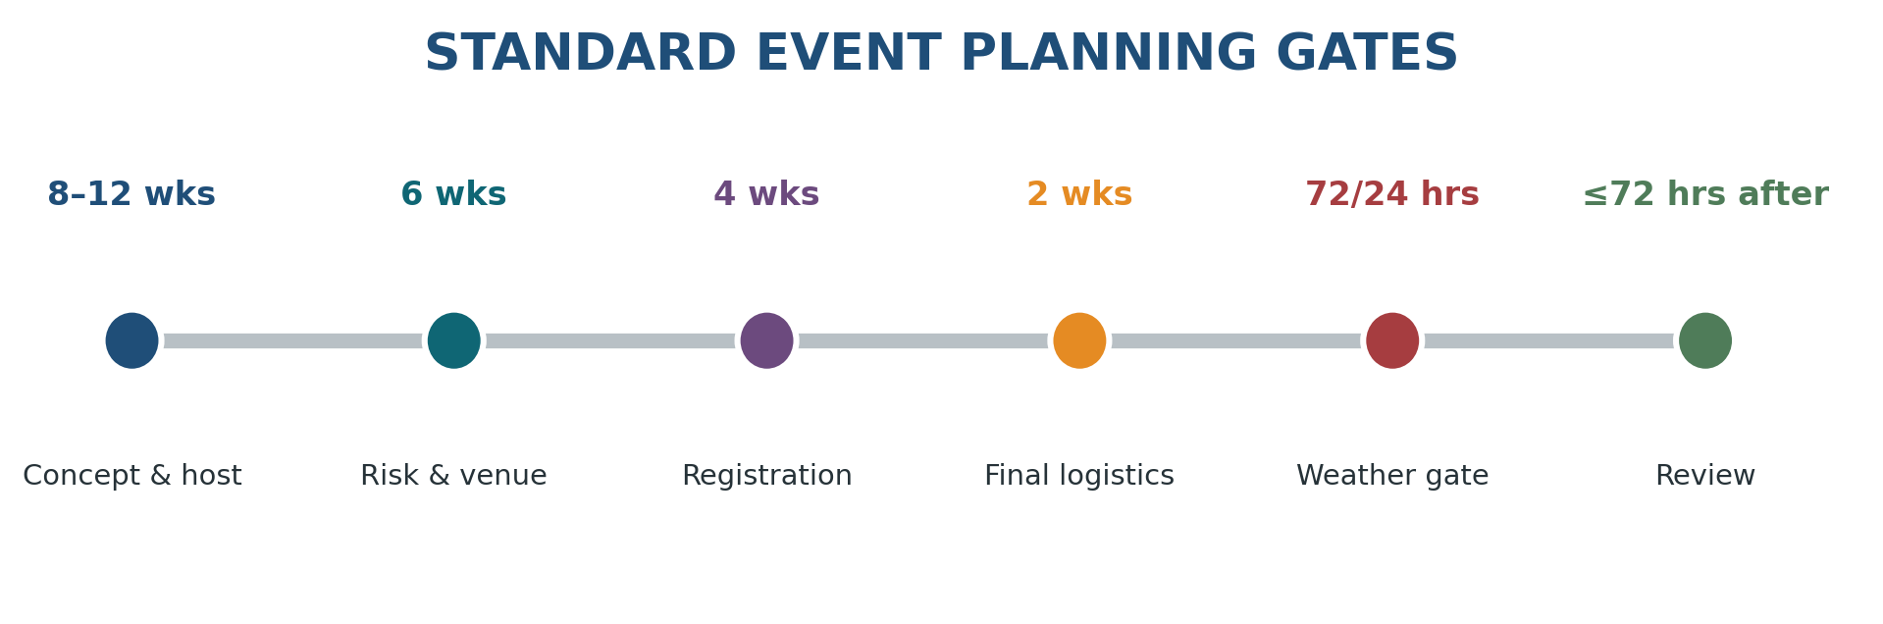
Figure 5. Standard planning timeline.
Gate | Required evidence | Go / no-go owner
Concept (8–12 weeks) | Purpose, tier, proposed date, host, travel burden, rough cost and curriculum fit. | Program Director.
Venue/risk (6 weeks) | Host confirmation, venue rules, risk class, insurance/permission questions and accessibility. | Event + Safety Leads.
Registration (4 weeks) | Family notice, consent level, medical/allergy update, payment/refund terms and transport plan. | Event Lead.
Final logistics (2 weeks) | Headcount, roles, food, supplies, child plan, manifest and emergency plan. | Event Lead with functional leads.
Weather (72/24 hours) | Forecast, warnings, route and host status; cancellation message ready. | Safety Lead.
Post-event (≤72 hours) | Attendance, incidents, actual cost, host feedback and improvement actions. | Event + Safety Leads.

9.4 Risk classification
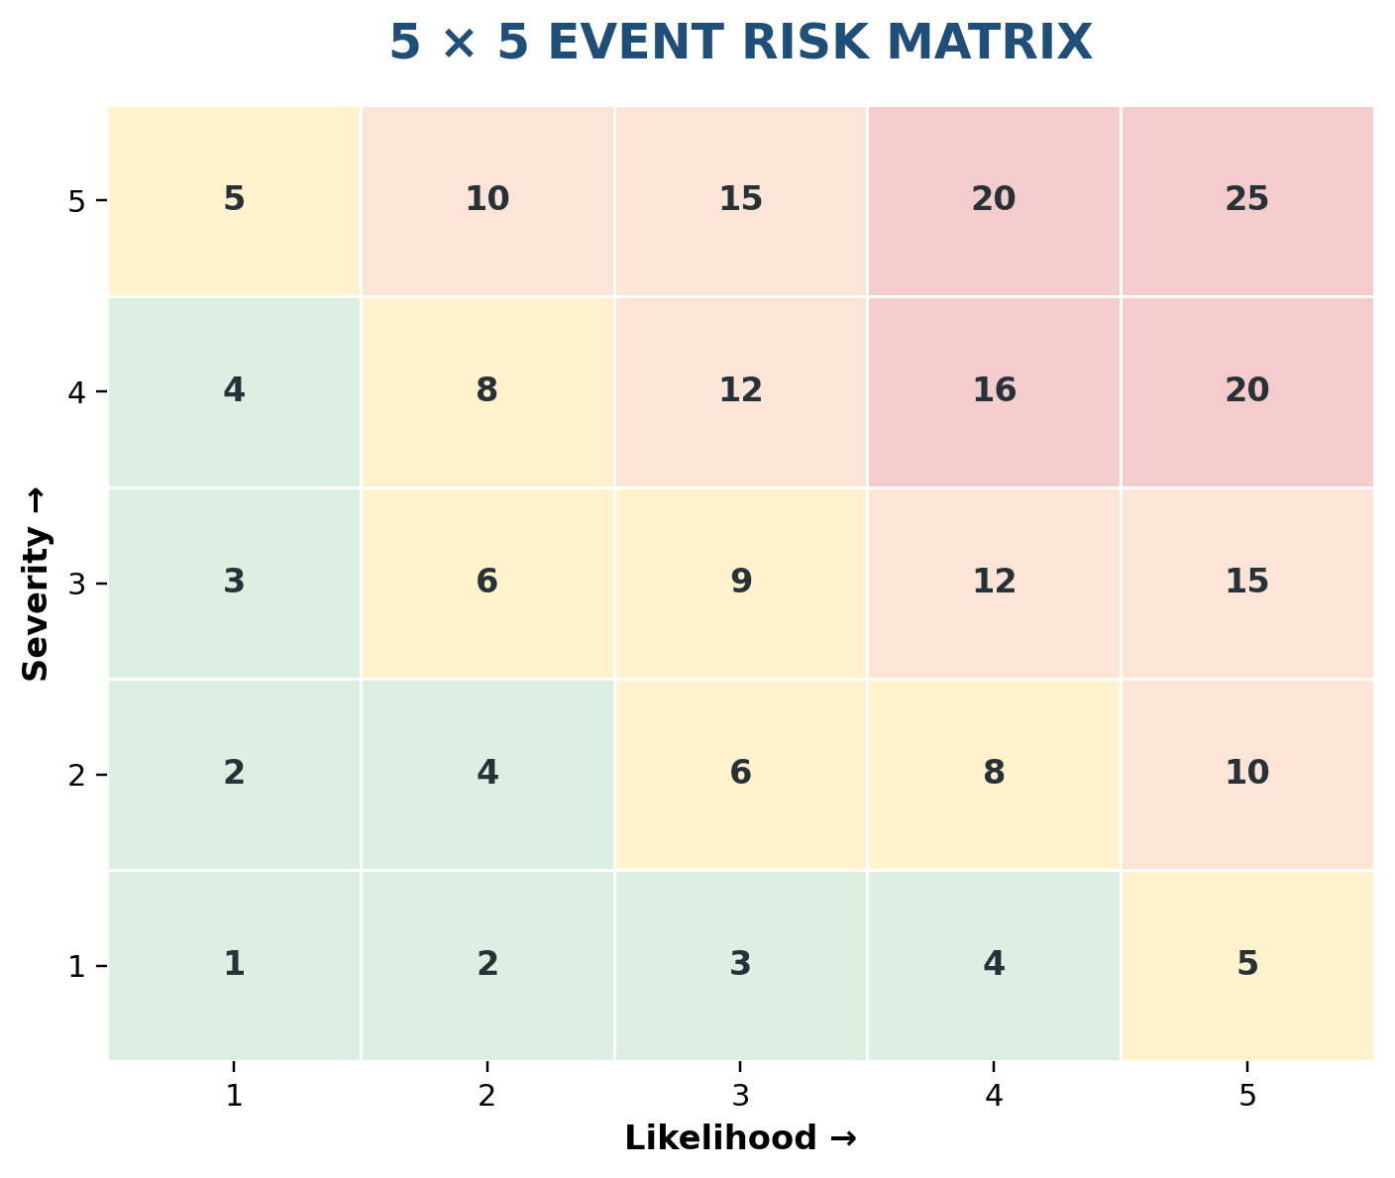
Figure 6. Five-by-five event risk matrix.
Class | Examples | Required controls
Low | Temple room, local park picnic, short paved japa walk. | Named lead, headcount, weather check, emergency contacts.
Medium | Crowded festival, farm service, moderate hike, long day trip. | Written risk review, consent, separate Safety Lead, medical and transport plan.
High | Kayaking, overnight, remote hiking, international travel. | Specialist operator/guide, event-specific consent, insurance/legal review, enhanced emergency and safeguarding plan.

Risk acceptance rule
Residual risk scores of 16–25 are not accepted by KUTUMBA. Redesign, transfer to a qualified provider or cancel. Scores of 10–15 require explicit Safety Lead and Program Director sign-off.

10 | Safeguarding, supervision, inclusion and media  Parents remain responsible; custody changes only through explicit process.

10.1 Parent responsibility and custody
• At public festivals, temples, farms, parks and travel stops, families remain family units and parents supervise their children.
• KUTUMBA coordination does not silently create child custody or one-to-one mentoring.
• A child enters a designated KUTUMBA children’s activity only through an explicit check-in and check-out process.
• The two-adult and visible-space principles continue off-site.
• No adult privately messages, transports, counsels or isolates an unrelated child outside the approved safeguarding process.
• Teens may assist with activities but never replace the responsible adult safety structure.

10.2 Off-site supervision plan
Control | Standard
Family units | Default supervision model.
Designated child activity | Two trained adults, visible space, attendance list and parent handoff.
Buddy system | Secondary control only; never a substitute for adults.
Headcounts | Before departure, after arrival, before/after location changes, before venue departure and at final return.
Restrooms | Parent assists own young child where possible; no unrelated adult alone with a child in a closed restroom.
Crowds | Child contact card, fixed reunification point and distinctive family identifier if useful.
Night/overnight | Children remain with parents; no unrelated adult-child sleeping arrangement.

10.3 Lost-child response
1. Stop group movement and notify the Event and Safety Leads.
2. Confirm the child’s description, last known location, parent and medical concerns.
3. Keep one adult and the parent at the reunification point.
4. Notify venue security or host immediately and assign adults to controlled search zones.
5. Do not send children or teenagers to search.
6. Contact emergency services when warranted or required by the venue.
7. Document actions, timing and outcome; complete a formal incident review.

10.4 Accessibility and inclusion
☐ Mobility, restroom, seating and parking needs asked during registration. | ☐ Alternative role or shorter route available where practical.
☐ Quiet/low-sensory option identified for crowded or loud festivals. | ☐ Instructions provided in clear written and verbal form.
☐ No public disclosure of disability, medical, financial or behavioral needs. | ☐ Food/allergy accommodations are explicit, not assumed.
☐ Financial assistance is private and never linked to service status. | ☐ Families may leave early without shame when children, health or safety require it.

10.5 Photography, media and live location
• Use separate, revocable media consent; event participation is not consent to publication.
• Follow temple, farm, sacred-space and host restrictions before KUTUMBA preferences.
• Do not post live location, travel status, hotel details or identifying child information publicly.
• Do not tag minors or publish names without specific parent permission.
• Avoid images of children in distress, correction, medical care, changing areas or vulnerable situations.
• Store approved media in the controlled operational library, not in the public Git repository.
• Assign a designated photographer when possible; uncontrolled participant photography remains subject to the family covenant.

11 | Transport, carpools and travel control  The safest Year 1 model is family-arranged transportation.

11.1 Transport model
KUTUMBA may coordinate available seats, meeting points and manifests, but should not present itself as a transportation provider. In Year 1, each family should normally arrange its own transportation.
Transport mode | Working rule
Family self-drive | Default; family retains responsibility for vehicle, restraints, timing and child supervision.
Shared carpool with parent present | Permitted when families agree and driver/vehicle details are recorded.
Minor travels without parent | Written authorization, approved driver, appropriate restraint and no one-adult/one-unrelated-child arrangement except documented emergency.
Rental van/bus | Use licensed provider; confirm insurance, seat belts, child-restraint feasibility and driver terms.
International travel | Outside founding-stage scope; temple/yātrā operator leads with full travel planning.

11.2 Driver and vehicle controls
☐ Valid driver licence and current insurance confirmed by attestation. | ☐ Working seat belt for every occupant; no overcrowding.
☐ No texting, handheld phone use, alcohol, intoxicants, impairment or unsafe fatigue. | ☐ Parents provide and install their own child restraint unless an approved alternative is documented.
☐ Destination, route, meeting point and emergency contact supplied. | ☐ Driver and passenger manifest maintained privately.
☐ Arrival and departure confirmed with Transport Coordinator. | ☐ No child is left alone in a vehicle.

11.3 Pennsylvania child-passenger baseline
Pennsylvania requires rear-facing restraints for children under two until manufacturer limits are exceeded, approved child safety seats for children under four, booster seats from ages four through seven, and seat belts from age eight; best practice keeps children in the back seat through age twelve [S16]. KUTUMBA treats these as minimums, not a complete transport policy.
Legal refresh
Transport laws and insurance terms can change. Recheck Pennsylvania requirements and any other state crossed before publishing each annual policy or operating an out-of-state trip.

11.4 Travel-day controls
• Use one primary meeting point and one published departure deadline.
• Do not make the whole convoy wait indefinitely for late families; publish a direct-arrival fallback.
• Drivers do not attempt to maintain a tight convoy at the expense of traffic safety.
• Schedule rest stops for trips over approximately two hours and account for children’s needs.
• Do not distribute sensitive manifests in open messaging groups.
• For overnight travel, confirm room allocation and arrival before departure.

12 | Medical, food, weather and emergency operations  Simple plans, clear thresholds and no improvisation during an incident.

12.1 Medical and allergy readiness
Requirement | Standard
Information | Current emergency contact, allergies, major conditions, mobility limits and essential medication availability.
Medication | Parents/participants normally carry and administer their own medication; exceptions require formal authorization and trained personnel.
First aid | Named first-aid adult and clearly identified kit; role does not imply medical diagnosis.
Emergency action | Call 911 for urgent danger; follow dispatcher and venue instructions; notify parent immediately.
Documentation | Record facts, actions and witnesses; do not speculate about fault or diagnosis.
Privacy | Share information only with those who need it for safety; do not store in Git or public group chat.

12.2 Event food and water
• Use the approved no-onion/no-garlic and allergy process from the Prasāda Operations workstream.
• Separate eating areas from animal environments; CDC advises handwashing after animal contact and before eating [S17].
• Bring sufficient potable water and publish refill availability.
• For hot weather, schedule water breaks rather than relying on children to self-regulate.
• Commercial food is not labeled prasāda unless handled and offered through the approved process.
• Do not create elaborate festival menus that increase food safety, cost and volunteer burden.

12.3 Weather authority and thresholds
Hazard | Action
Lightning / thunder | Stop outdoor activity; move to a substantial enclosed building or hard-topped vehicle. Wait at least 30 minutes after the last thunder before resuming [S20].
Severe thunderstorm / tornado warning | Cancel, evacuate or shelter according to venue and local authority instructions.
Flash flood / high water | Cancel affected route or water activity; never enter flooded roads or trails.
Heat | Move activity to cooler hours, shorten duration, increase water/shade breaks and provide an indoor/low-exertion alternative. Children rely on adults to stay cool and hydrated [S23–S24].
Snow / ice | Cancel when roads, parking, trails or venue access are unsafe; do not pressure families to travel.
Air quality / smoke | Modify or cancel strenuous outdoor activity using current official guidance.
Host closure | Cancel or redesign; do not relocate informally without a new risk check.

12.4 Go / modify / cancel protocol
1. At 72 hours, Safety Lead records the preliminary forecast, warnings and venue status.
2. At 24 hours, issue a formal go, modified or cancelled decision with clothing, route and timing updates.
3. On event day, the Safety Lead monitors conditions and identifies shelter/evacuation points.
4. Any participant may report a safety concern; only the Safety Lead or emergency authority closes the decision.
5. A cancellation normally becomes a protected rest week or simple home activity, not a compulsory make-up event.

12.5 Emergency plan minimum fields
☐ Venue address, GPS location and emergency entrance. | ☐ Nearest hospital/urgent care or ranger/venue security contact.
☐ Emergency services instructions and cell coverage limitations. | ☐ Adult and child roster; transport manifest.
☐ Parent contacts and critical allergy/medical alerts. | ☐ First-aid kit and emergency medication location.
☐ Shelter, evacuation and reunification point. | ☐ Lost-child response and headcount checkpoints.
☐ Incident lead, communications lead and host contact. | ☐ Alternative route or cancellation message.

Emergency planning basis
Ready.gov emphasizes alerts, shelter plans, evacuation routes and family communication. KUTUMBA uses the same practical categories, scaled to a small family event [S25].

13 | Budget, affordability and financial controls  No hidden cost, faith pressure or uncontrolled prepayment.

13.1 Year 1 financial policy
• No pooled annual activity fund during the founding stage.
• Families pay venues directly where possible.
• Every cost, cancellation term, nonrefundable amount and subsidy is disclosed before commitment.
• Donations are optional and separate from required participation costs.
• No public identification of families requesting financial help.
• No mandatory overnight or high-cost event in Year 1.
• The core team reviews actual costs after six to twelve months before creating any fund.

13.2 Cost bands
Band | Planning range per family | Examples | Portfolio rule
Green | $0–$25 | Park, temple service, local picnic, short trail. | At least two annual replacement experiences should be Green where feasible.
Amber | $26–$100 | Farm tour/service, admission, regional day trip. | No more than two mandatory Amber events in Year 1.
Red | Over $100 or lodging | Overnight yātrā, complex rental or long-distance travel. | No mandatory Red event in Year 1.

These are internal planning bands, not venue quotations. Refresh them when costs materially change.

13.3 Event budget fields
Category | Estimate | Actual | Notes / refund terms
Venue / reservation
Admission / program fee
Host donation
Prasāda / water
Transport / tolls / parking
Equipment / rental
Supplies / printing
Lodging
Contingency (normally 10%)
Total and per-family amount

13.4 Approval and reimbursement
• One person proposes expenditure; another approves when practical.
• Retain receipts and reconcile actual versus approved cost within seven days.
• Do not reimburse unapproved upgrades, souvenirs or personal purchases.
• Material cost increase requires a new family decision, not silent escalation.
• Unused subsidy or donation is handled under the approved financial policy and not casually retained by an individual.

14 | Communication, forms and packing  Families should know exactly what is required, optional and prohibited.

14.1 Standard communication sequence
Timing | Message
4–6 weeks | Save-the-date: purpose, tier, location, rough cost, travel and registration deadline.
2–4 weeks | Registration: consent level, medical/allergy update, transport request and payment terms.
7 days | Final guide: schedule, roles, packing, dress, food, meeting point, child plan and weather posture.
24 hours | Go / modify / cancel decision.
Event day | Arrival instructions, emergency-only contact and checkout reminder.
Within 24 hours after | Reflection link and gratitude.
Within 72 hours after | Leadership review and host follow-up.

14.2 Event notice — required content
☐ Why KUTUMBA is doing the event. | ☐ Whether it replaces the weekly program.
☐ Mandatory, optional or home-observance status. | ☐ Date, start, finish, address and travel estimate.
☐ Host/temple relationship and expected conduct. | ☐ Cost, payment, refund and subsidy process.
☐ Child custody and supervision model. | ☐ Transport and car-seat responsibility.
☐ Food, allergies and water. | ☐ Accessibility, restrooms and route difficulty.
☐ Clothing and packing. | ☐ Weather and cancellation decision time.
☐ Photography/media rules. | ☐ Registration deadline and contact.

14.3 Packing lists

Universal day trip
☐ Water bottle | ☐ Weather-appropriate modest clothing
☐ Comfortable footwear | ☐ Personal medication
☐ Child contact card | ☐ Small japa bag
☐ Sun/insect protection | ☐ Rain layer
☐ Spare child clothing where needed

Temple / festival
☐ Clean devotional clothing | ☐ Shawl or layer
☐ Water | ☐ Child contact card
☐ Quiet seated activity for young children | ☐ Meeting-point details
☐ Minimal valuables

Farm service
☐ Closed-toe shoes or boots | ☐ Work gloves
☐ Washable clothing | ☐ Hat
☐ Water | ☐ Change of socks/shoes
☐ Bag for dirty clothing

Hike / trek
☐ Trail shoes | ☐ Water
☐ Layers/rain shell | ☐ Sun/insect protection
☐ Approved trail prasāda/snack | ☐ Offline map
☐ Essential medication

Kayaking — later stage
☐ Properly fitted life jacket | ☐ Quick-drying clothing
☐ Secured footwear | ☐ Sun protection
☐ Water | ☐ Dry change of clothes
☐ Waterproof medication storage | ☐ No loose valuables

Overnight yātrā
☐ Temple and sleeping clothing | ☐ Toiletries and medication
☐ Flashlight | ☐ Japa/reading materials
☐ Family emergency info | ☐ Bedding if required
☐ Labelled luggage | ☐ Child comfort item

14.4 Registration and consent levels
Event type | Consent / record
Normal local park or temple visit | Annual participation consent plus event registration.
Public festival or farm service | Event acknowledgement, medical/allergy update and transport selection.
Minor travels without parent | Written transport authorization and approved driver/restraint.
Kayaking or other high-risk activity | Event-specific risk acknowledgement and operator waiver as applicable.
Overnight / out-of-state | Full trip consent, rooming acknowledgement, medical update and emergency plan.
Photography | Separate media consent; not bundled as a condition of participation.

15 | Reflection, measurement and annual improvement  The experience is incomplete until learning is integrated.

15.1 Family reflection
Prompt | Adult / older child | Young child option
Learning | What did we learn about Kṛṣṇa, a devotee, service or the place? | Draw or point to one remembered scene.
Service | What service did we perform and for whom? | Name one helpful action.
Gratitude | Who helped us and what are we grateful for? | Say one thank-you.
Memory | What moment should our family remember? | Choose one picture or object.
Application | What will we bring into our home this week? | Pick one simple practice.

15.2 Leadership review within 72 hours
☐ Attendance and late cancellation pattern. | ☐ Whether the devotional purpose was achieved.
☐ Child-supervision defects or safeguarding concerns. | ☐ Medical, allergy or food issue.
☐ Weather, route, transport or timing defect. | ☐ Incident or near miss.
☐ Host feedback and relationship impact. | ☐ Actual cost and refund issue.
☐ Accessibility or inclusion problem. | ☐ One change required before repetition.
☐ Owner and due date for each action. | ☐ Whether the event remains in the annual portfolio.

15.3 Success measures
Domain | Evidence | Bad metric to avoid
Devotional memory | Families can explain one teaching, person, place or service after 1–4 weeks. | Number of photos or social-media reactions.
Practice | At least one realistic home/temple action adopted. | Publicly displayed commitments or round counts.
Belonging | Families report being welcomed and useful. | Popularity of hosts or performers.
Temple connection | More respectful service and participation. | KUTUMBA attendance substituting for temple life.
Safety | No preventable incident; near misses produce corrective action. | Claiming success because “nothing happened.”
Burden | Families can participate without chronic exhaustion or cost pressure. | Maximizing events or attendance at every festival.

15.4 Annual portfolio review
1. Compare planned versus actual active/non-program weeks.
2. Review attendance, cancellations, incidents, cost and family feedback by event.
3. Identify one event to retain, one to redesign and one not to repeat.
4. Review whether temple relationships strengthened.
5. Confirm whether the cohort is ready for a higher-complexity Year 2 or Year 3 experience.
6. Update policies, templates and source references before publishing the next calendar.

16 | Implementation roadmap  What must exist before the first experiential event.

16.1 Minimum launch package
☐ Annual 52-week calendar with clear tiers and four replacement slots. | ☐ Named Calendar Lead, Temple Liaison and Children/Safety Lead.
☐ Event brief and risk-assessment templates approved. | ☐ Annual consent, media consent, medical/allergy and transport forms.
☐ Emergency contact and incident process. | ☐ Weather monitoring and cancellation communication process.
☐ First-aid kit and trained first-aid adult identified. | ☐ Host relationship confirmed for the first outing.
☐ Family orientation on custody, carpool, cost and conduct. | ☐ Secure operational storage separate from Git.

16.2 Ninety-day implementation plan
Period | Deliverables
Days 1–30 | Approve permanent policy; identify roles; select authorized calendar source; choose provisional Year 1 portfolio; consult temple liaison.
Days 31–60 | Create forms, event templates, emergency kit, communication library and secure storage; conduct tabletop lost-child/weather scenarios.
Days 61–90 | Plan first low-risk local event through all gates; orient families; operate; review within 72 hours; fix defects before the next outing.

16.3 Clear recommendation
Adopt this operating position
Start Year 1 with one local Ratha-yātrā, Janmāṣṭamī week, one Gītā Valley cow/service day and one local nature retreat. Integrate Gaura-pūrṇimā, Rāma-navamī, Nṛsiṁha-caturdaśī, Dāmodara/Govardhana and Gītā Jayantī into normal curriculum weeks. Defer New Vrindaban to Year 2, kayaking to Year 2 or later, camping to Year 3 or later, and KUTUMBA-led international pilgrimage until a qualified temple/ISKCON yātrā structure is available.

A | Appendix A — Annual calendar worksheet  Use this after authorized festival dates and school breaks are known.

Week | Date | Cycle / festival | Tier | Location | Lead | Status
1
2
3
4
5
6
7
8
9
10
11
12
13
14
15
16
17
18
19
20
21
22
23
24
25
26
27
28
29
30
31
32
33
34
35
36
37
38
39
40
41
42
43
44
45
46
47
48
49
50
51
52

B | Appendix B — Event brief template  One page of purpose and scope before logistics multiply.

Field | Entry
Event title / ID
Date / time / tier
Event Lead / Safety Lead
Host / temple contact
Devotional purpose
Learning outcomes
Target families / ages
Location / travel time
Proposed schedule
Service assignment
Child supervision model
Transport model
Food / water
Accessibility
Rough budget / refund terms
Primary risks
Weather cancellation time
Required approvals

C | Appendix C — Risk assessment and controls  Rate inherent risk, controls and residual risk.

Hazard | Who may be harmed | Existing controls | L | S | Score | Further action / owner | Residual

Likelihood and severity are scored 1–5. Score = likelihood × severity. Apply the acceptance rule in Section 9.4.

D | Appendix D — Event emergency plan  Complete and carry a restricted-access copy.

Emergency field | Entry
Venue address / GPS
Emergency entrance / meeting point
Host security / ranger contact
Nearest emergency care
Event Lead mobile
Safety Lead mobile
Children Lead mobile
First-aid adult / kit location
Reunification point
Shelter / evacuation location
Transport manifest location
Critical medical/allergy alerts
Lost-child search zones
Emergency message template
Post-incident reporting owner

E | Appendix E — Carpool manifest  Restricted operational record; do not place in Git.

Driver / mobile | Vehicle | Passengers | Child restraint confirmed | Depart | Arrive / checkout

F | Appendix F — Family reflection sheet  Complete during return travel or within 24 hours.

What did our family learn about Kṛṣṇa, a devotee, service or this place?
________________________________________________________________________________
________________________________________________________________________________
________________________________________________________________________________
What service did we perform?
________________________________________________________________________________
________________________________________________________________________________
________________________________________________________________________________
Who helped us, and what are we grateful for?
________________________________________________________________________________
________________________________________________________________________________
________________________________________________________________________________
What moment do we want to remember?
________________________________________________________________________________
________________________________________________________________________________
________________________________________________________________________________
What one practice will we bring home this week?
________________________________________________________________________________
________________________________________________________________________________
________________________________________________________________________________

G | Appendix G — Event review record  Close within 72 hours and assign corrective actions.

Review item | Finding | Action | Owner / due
Devotional purpose achieved?
Attendance / late changes
Host relationship
Child supervision / safeguarding
Medical / allergy / food
Transport / timing
Weather / venue
Incident / near miss
Accessibility / inclusion
Budget estimate vs actual
Family feedback
Repeat / redesign / retire

H | Appendix H — Research and source register  Primary and official sources used for this framework.

S01 | KUTUMBA Master Operating Model  Project source document supplied for this workstream.  Internal project document

S02 | GBC 2001 Resolution 608 — Vaiṣṇava Calendar  Explains the multi-calendar approach and local calculation rationale.  https://gbc.iskcon.org/2001/

S03 | Śrīmad-Bhāgavatam, Canto 7, Chapter 14 — Ideal Family Life  Householder association, hearing, prasāda, care for living beings and pilgrimage.  https://vedabase.io/en/library/sb/7/14/

S04 | Caitanya-caritāmṛta, Madhya-līlā, Chapter 13  Lord Caitanya’s Ratha-yātrā kīrtana, dancing and service.  https://vedabase.io/en/library/cc/madhya/13/

S05 | Caitanya-caritāmṛta, Ādi-līlā, Chapter 3  Reasons and scriptural basis for Lord Caitanya’s appearance.  https://vedabase.io/en/library/cc/adi/3/

S06 | Śrīmad-Bhāgavatam, Canto 9, Chapter 10  Pastimes of Lord Rāmacandra.  https://vedabase.io/en/library/sb/9/10/

S07 | Śrīmad-Bhāgavatam, Canto 7, Chapters 8–9  Prahlāda and Lord Nṛsiṁhadeva.  https://vedabase.io/en/library/sb/7/8/

S08 | Śrīmad-Bhāgavatam, Canto 10, Chapter 3  The appearance of Lord Kṛṣṇa.  https://vedabase.io/en/library/sb/10/3/

S09 | Śrīmad-Bhāgavatam, Canto 10, Chapter 9  Mother Yaśodā binds Lord Kṛṣṇa.  https://vedabase.io/en/library/sb/10/9/

S10 | Śrīmad-Bhāgavatam, Canto 10, Chapters 24–27  Govardhana worship and protection.  https://vedabase.io/en/library/sb/10/24/

S11 | Bhagavad-gītā As It Is 18.66  Surrender to Kṛṣṇa and conclusion of the Gītā.  https://vedabase.io/en/library/bg/18/66/

S12 | Gītā Valley — official site  Farm mission, visits, workshops, lodging and cow protection.  https://gitavalley.org/

S13 | New Vrindaban — official site  Temple community, visitor information and devotional experiences.  https://www.newvrindaban.com/

S14 | Palace Lodge — official New Vrindaban page  Family rooms, cabins and lodging capacity.  https://www.newvrindaban.com/lodge

S15 | ISKCON Harrisburg Festival of India  Local Ratha-yātrā / Festival of India information.  https://www.iskconharrisburg.org/festivalofindia

S16 | PennDOT — Child Passenger Safety  Current Pennsylvania restraint requirements and best practices.  https://www.pa.gov/agencies/penndot/traveling-in-pa/safety/traffic-safety-driver-topics/child-passenger-safety

S17 | CDC — Farm Animals / Animal Exhibits  Handwashing, supervision and separation of eating from animal areas.  https://www.cdc.gov/healthy-pets/about/farm-animals.html

S18 | Pennsylvania Fish and Boat Commission — Life Jackets  Life-jacket requirements for children and paddlers.  https://www.pa.gov/agencies/fishandboat/boating/basics/equipment/life-jackets

S19 | Pennsylvania Fish and Boat Commission — Paddlesports Basics  Weather, float plan, conditions and paddling preparation.  https://www.pa.gov/agencies/fishandboat/boating/paddlesports/basics

S20 | National Weather Service — Lightning Safety and Outdoor Sports  Thirty-minute wait after last thunder and safe-shelter guidance.  https://www.weather.gov/safety/lightning-sports

S21 | National Park Service — Hike Smart  Planning, limits, equipment and route selection.  https://www.nps.gov/articles/hiking-safety.htm

S22 | National Park Service — Hiking with Kids  Family trip planning and age-appropriate engagement.  https://www.nps.gov/subjects/trails/hiking-with-kids.htm

S23 | CDC — Heat and Your Health  Shade, breaks and cooler-time scheduling.  https://www.cdc.gov/heat-health/about/index.html

S24 | CDC — Infants and Children and Heat  Children rely on adults to remain cool and hydrated.  https://www.cdc.gov/heat-health/risk-factors/infants-and-children.html

S25 | Ready.gov — Make a Plan  Alerts, shelter, evacuation and family communication planning.  https://www.ready.gov/plan

Source-use and annual verification note
Online sources were accessed on 29 June 2026. Venue offerings, prices, event dates, laws and safety guidance may change. Before each annual calendar and before every event, verify the current official source. Śrīla Prabhupāda’s books and approved ISKCON guidance remain the primary devotional authority; government and venue sources govern their respective safety and operational domains.

I | Appendix I — Final readiness gate  Do not release an event until every “required” item is closed.

☐ Purpose and tier approved. | ☐ Host/date/location confirmed.
☐ Risk assessment complete; residual risk accepted. | ☐ Event Lead and independent Safety Lead named where required.
☐ Child supervision and custody model published. | ☐ Consent, medical/allergy and media requirements collected.
☐ Transport and child-restraint responsibilities confirmed. | ☐ Food, water, restrooms and accessibility confirmed.
☐ Emergency plan and headcount process complete. | ☐ Weather decision owner, time and message prepared.
☐ Budget, payment and refund terms disclosed. | ☐ Packing list and conduct guidance sent.
☐ Temple/host liaison approved service and devotional plan. | ☐ Post-event reflection and review owners assigned.

Final stop question
Would the core team still run this event if attendance were lower, weather were less comfortable and no photographs were posted? If the answer is no, the design may be driven by image, momentum or sunk cost rather than devotional purpose.

